Investment Policy Statement

Presented to

Dr. Paul Ahn

Portfolio Management

FIN-5745

By

Alexandre Ly

47053031

04/20/26
Table of Contents
Section 1 – Scope and Purpose of IPS 2
1.1 Objectives of this Document 2
1.2 Document Governance 2
Section 2 – Governing Roles and Responsibilities 2
2.1 Investment Team under Dr. Paul Ahn 2
2.2 Decision-Making Authority 3
2.3 Client Responsibilities 3
Section 3 – Investment, Return, and Risk Objectives 3
3.1 Client Financial Profile 3
3.2 Return Objectives 4
3.3 Risk Tolerance Analysis 4
3.4 Investor Profiling Frameworks 5
3.5 Investment Constraints Summary 6
Section 4 – The ACWI Investment Strategy: AI-Energy Nexus 6
4.1 Investment Thesis: The AI-Energy Nexus play 6
4.2 Capital Allocation: From Risk Profile to Optimal Portfolio 7
4.3 Asset Class Allocation: Bond Portfolio 8
4.4 Security Selection: The Active Portfolio (Treynor-Black) 9
4.5 Individual Stock Analysis & GRID Thesis Rationale 11
4.6 Active Portfolio Construction Summary 14
4.7 Statistical Significance of Alpha Estimates: P-Value Analysis 15
Section 5 – Risk Management & Performance Evaluation 18
5.1 Risk Decomposition & Portfolio Beta 18
5.2 Correlation Structure 19
5.3 Performance Metrics: Active Portfolio vs. ACWI Index 20
5.4 Benchmark & Performance Measurement Protocol 20
Section 6 – Portfolio Valuation Analysis 20
6.1 Alpha Adjustment Methodology 20
6.2 Valuation vs. Active Weight Alignment 21
6.3 Bond Valuation & Duration Implications 21
Section 7 – Performance Measurement & Monitoring: Excel Model as a tool to meet Client’s Goals 22
7.1 The Portfolio Construction Bridge 22
7.2 KPI Monitoring Dashboard 23
7.3 Model Refresh Protocol 23
7.4 Reporting Check 24
Appendices 25
Appendix A – Investor Profiling Framework Summary 25
Appendix B – Glossary of Key Terms 25
Bibliography 26

Section 1 – Scope and Purpose of IPS

The mandate of this IPS serves as the governing roles and responsibilities for all discretionary portfolio decisions affecting Mr. Minh Tri Nguyen. The review of this written amendment signed by both the client and portfolio manager should be done at an annual frequency.
Effective of April 2026, this investment policy sets out the complete governance framework for the discretionary portfolio management mandate of Mr. Minh Tri Nguyen (The “Clients”), which is to the function as a binding contract between the Clients and the Portfolio Manager under Dr. Paul Ahn’s Investment Team, ensuring consistency with the Client’s objective, constraints, risk profile, and financial context.

Objectives of this Document
- To define the Client’s investment goals (return and risk) with qualitative and quantitative rationale;
- To implement Strategic Asset Allocation, tactical asset allocation and allowed investment brackets for each class;
- To draw out all crucial constraints pertaining time horizon, liquidity, legal, tax and individual considerations;
- To report the philosophy of active management and financial planning style through selection of equity assets;
- To determine the performance KPIs and discern the surveillance, readjustment and risk considerations procedures;
- To account for a clear record of precisely driven allocation methodology with known and trusted supporting materials and assumptions.

Document Governance
Review Frequency: Annual at minimum; ad hoc review triggered by any material change in client circumstances, market regime shift (defined as >15% portfolio drawdown), or amendment to the simulation mandate.
Amendment Protocol: Any substantive change to SAA, risk limits, or benchmarks requires written documentation and a client consultation meeting.
Reporting Cadence: Quarterly performance reports delivered against the blended benchmark. Annual IPS review includes full attribution analysis, benchmark validation, and risk parameter reassessment.

Section 2 – Governing Roles and Responsibilities

Governance efficacy depends on the precise mapping of accountability and the demarcation of functional boundaries between the portfolio manager and the client base

2.1 Investment Team under Dr. Paul Ahn
The portfolio is under management by Alexandre Ly operating under Dr. Paul Ahn’s Investment Group with a simulated discretionary mandate within Hult Business School Boston Portfolio Management programme. The portfolio manager has the responsibility as fiduciaries to prioritise the clients’ interests above all considerations, adhering to the spirit and letter of the CFA Institute’s Code of Ethics and Standards of Professional Conduct.

2.2 Decision-Making Authority
- Tactical demarcations within the allocated range (See Capital Allocation Table, Section 4.2): Discretionary authority of portfolio manager;
- Any modifications to SAA or risk boundaries: Require the Clients and portfolio manager consensus and written IPS amendment;
- Concentration Limits: Positions exceeding 3% of the portfolio require a formal request and the Clients approval.

2.3 Client Responsibilities
The Client’s responsibilities lies in the timely disclosure of any material changes in their personal or financial circumstances. This includes changes in employment, significant undisclosed expenditures (>$25,000), family composition, inheritance or windfall receipt, or changes in risk appetite.

Section 3 – Investment, Return, and Risk Objectives

The following section presents a comprehensive quantitative and qualitative analysis of the Clients’ financial profile, return targets, and risk tolerance, supported by 2026 market data and investor profiling frameworks.

3.1 Client Financial Profile
The table below provides a structured snapshot of the Client’s financial state as the basis for all subsequent investment decisions. Total gross investable liquid assets are estimated at approximately $81,000, with an additional $186,000 in net real estate equity held as a long-term, illiquid asset not included in the investable portfolio.

Profile Dimension | Mr. Minh Tri Nguyen
Age/Stage | Mid-to-late 30s/ Accumulation Phase
Employment | Full-Time – Career-Driven Professional
Primary Assets | $35K Employer Stock; $46K Money Market
Real Estate | Joint: $186K Net Equity (Primary Residence)
Risk Tolerance | [HIGH] Strong Human Capital, Career-Driven Saver
Special Consideration | Investments exclusively in the utilities sector
Return Objective | Long-term Capital Appreciation
Liquidity Needs | [LOW] Salaries cover living expenses
Investor Profile (BBK) | Individualist
Investor Profile (CFA) | Individualist / Net Saver
Figure 3.1 — Client Snapshot: Mr. Minh Tri Nguyen (April 2026). Source: Interview data, IPS analysis
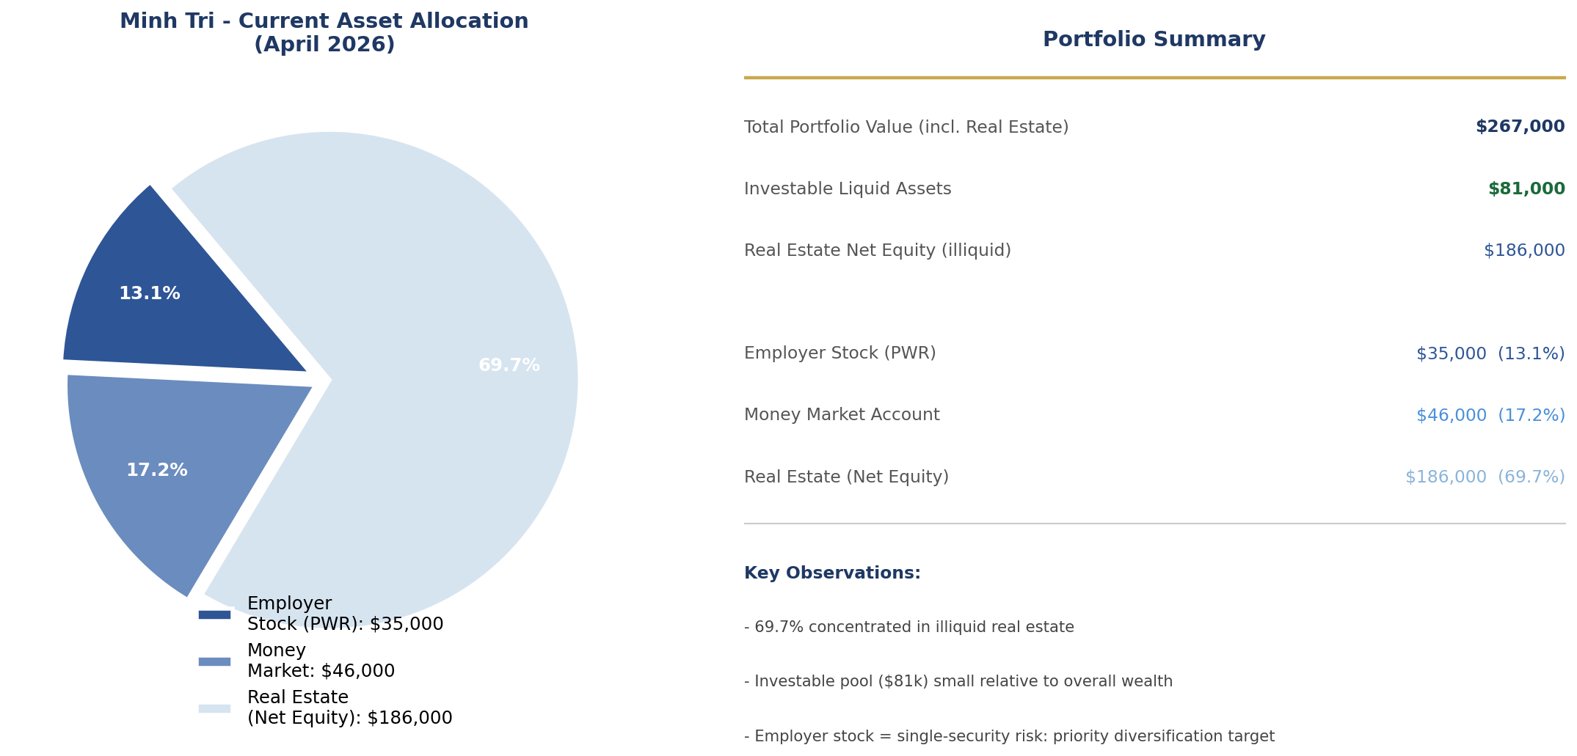

Figure 3.2 — Current Tactical Asset Allocation. current holdings including real estate equity. Source: Interview data, IPS analysis.

3.2 Return Objectives
Primary Objective: Long-term Capital Appreciation. Income generation is a secondary consideration given the Client’s 30-year horizon. The consideration of exclusively investing into energy transition companies stems from the specific instruction of the client.
Quantitative Target: Net annualised total return 8%-11% over rolling 5-year periods. This range is calibrated to the weighted blended return assumption of the 2026 tactical allocation described in section 4.

3.3 Risk Tolerance Analysis
Risk tolerance is evaluated along two independent dimensions per the CFA Institute Framework: the objective capacity to bear risk (quantitative assessment of wealth, income, and horizon) and the subjective willingness to take risk (behavioural assessment via investor profiling frameworks). Both dimensions must be explicitly documented and reconciled before a risk classification is assigned.

Risk Dimension | Rating | Rationale & Evidence
Objective Ability | HIGH | Gross investable liquid assets ~$81k (excl. real estate). Salaries fully adequate to sustain lifestyle without drawing on portfolio. $186k net real estate equity provides additional wealth buffer. 30-year horizon enables full market-cycle recovery.
Subjective Willingness | HIGH | Client explicitly seek capital appreciation; comfort with equity-dominant portfolio. BBK Individualist classification — rational risk-taking, not impulsive. CFA Net Saver — focuses on long-run wealth accumulation.
Overall Risk Tolerance | HIGH | Objective and subjective dimensions fully aligned. Portfolio is structured for growth-oriented mandate with documented downside guardrails (max drawdown policy, VaR limits).
Liquidity Risk | LOW | Salary fully cover expenses. No near-term large expenditure obligations beyond existing mortgage.
Horizon Risk | LOW | ~30-year investment horizon means short-term volatility is tolerable. Time diversification supports equity overweight without undue sequence-of-returns risk.
Concentration Risk | MODERATE | Currently concentrated: employer stock ($35k) represents ~23% of liquid investable assets — a significant single-security and employment-correlated risk. IPS mandates diversification into proposed SAA. Employer stock to be reduced below 5% single-security cap.
Currency Risk | MODERATE | U.S. and international equity allocations introduce CAD/USD exposure. Managed via 50% CAD-hedge on U.S. equity sleeve.
Tax Risk | MODERATE | Dividend income and capital gains taxed at Canadian marginal rates. TFSA/RRSP wrappers prioritised for high-income-generating assets. Tax-loss harvesting employed in taxable accounts.
Table 3.3 — Risk Tolerance Assessment Matrix. Colour-coded by severity: Green = Low risk constraint, Amber = Moderate, Blue = High risk capacity. Source: IPS analysis.

3.4 Investor Profiling Frameworks

3.4.1 Barnewall Two-Way Model (1987)
The Barnewall model classifies investors as either Passive (Wealth inherited or received without risk-taking) or Active (accumulated wealth through entrepreneurship, career achievement, or calculated risk-taking). Mr. Minh-Tri Nguyen qualifies as Active Investor: his financial position has been built through career achievement, disciplined saving, and prior real estate appreciation. Client demonstrates willingness to sacrifice current consumption for future capital growth, a hallmark of active investor behaviour (Barnewall, 1987).

Implication: An active management mandate with a growth orientation is fully consistent with this classification.

3.4.2 Bailard, Biehl & Kaiser (BBK) Model (1986)
The BBK model classifies investors on two axes: Confident vs. Anxious (emotional dimension) and Careful vs. Impetuous (cognitive dimension). The resulting quadrants are: Individualist (Confident and Careful), Guardian (Anxious and Careful), Adventurer (Confident and Impetuous) and Celebrity (Anxious and Impetuous). Client will be classified as Individualists – he possesses high financial literacy, seek professional advice to optimise decisions rather than acting on impulse, and seems comfortable with calculated portfolio risk. This classification directly supports a research-driven active management approach where investment decisions are grounded in quantitative analysis and transparent rationale (BBK, 1986).

3.4.3 CFA Institute Investor Typology
Under the CFA Institute’s private wealth management framework, Client is classified as an Individualist Net Saver. Net Savers accumulate wealth beyond consumption needs, making them well-suited for long-horizon growth mandates. The Individualists bias means the Client responds well to evidence-based investment rationale and is receptive to formal risk management structures (CFA Institute, 2022).

3.5 Investment Constraints Summary
Investment Horizon: Approximately 30 years. The Clients are in their early-to-mid 30s and target retirement approximately age 65. This extended horizon is the single most important determinant of portfolio construction, justifying a structural overweight to growth assets.
Liquidity Needs: Low. His salary covers his living expenses and even beyond to allow him to contribute more to his retirement plan.
Tax Considerations: Moderate. Dividend Income and capital gains are taxed at Canadian marginal rates. TFSA and RRSP wrappers should be maximized first, prioritizing high-income-generating assets (bond, REITs) in registered accounts. Tax-loss harvesting is employed in taxable accounts where applicable.
Legal Constraints: None identified as of April 2026.
Specific Constraints: Future family formation may increase liquidity requirements over a 3–5-year horizon. No immediate income reduction scenarios are anticipated.

Section 4 – The ACWI Investment Strategy: AI-Energy Nexus

Section 4-7 are built directly from the ACWI_index_FV.xlsx portfolio model. All return, risk, alpha, beta, and allocation figures are sourced directly from the model (Panels A-G, Capital Allocation, Asset Classes Allocation sheets). All data as of April 15th, 2026.

4.1 Investment Thesis: The AI-Energy Nexus play
The core investment thesis driving this portfolio is the structural intersection of three converging trends (1) the exponential growth in artificial intelligence computing requirements; (2) the resulting surge in electricity demand that AI data centres, hyperscale computing, and electrification are placing on the North American and global power grid; and (3) the urgency and scale of smart grid infrastructure investment required to accommodate this demand while meeting ESG and emissions targets.

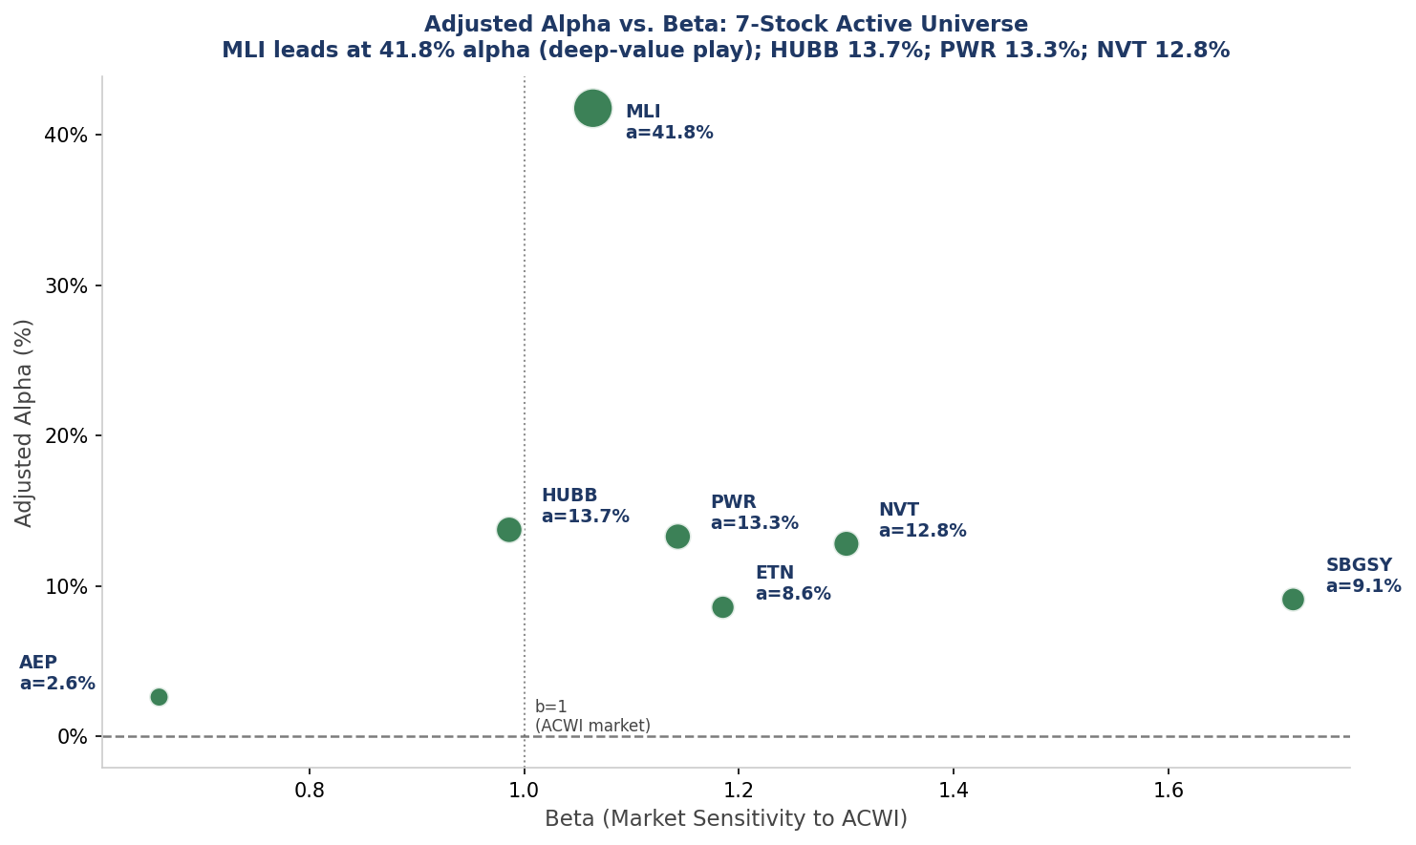
Figure 4.1 - The AI-Energy Nexus Investment Thesis: AI Surge Power Demand Smart Grid Infrastructure Risk-Adjusted Alpha.
Source: IPS team construction.

According to the US Department of Energy, electricity demand from data centers alone is projected to grow by 40% or more by 2030, a trajectory that requires and estimated $2-$5 trillion in grid infrastructure investment over the next decade. Crucially, this demand cannot be met by simply building more generation capacity, the transmission and distribution infrastructure, smart metering systems, power management hardware, and grid automation technology must all be upgraded simultaneously. This is the structural opportunity the AI-Energy Nexus portfolio captures.

The benchmark for this strategy is the iShares MSCI ACWI ETF (ticker: ACWI, current price $148.80 as of April 15, 2026), a globally diversified equity benchmark covering developed and emerging markets, which tracks a diversified basket of companies across the smart grid value chain: from utilities and grid operators to smart meter manufacturers and industrial electrical equipment providers. Rather than merely tracking this index passively, the portfolio employs an active overlay (Treynor-Black methodology) to tilt positions toward the highest-alpha securities within this universe, generating superior risk-adjusted returns while preserving the ESG integrity of the underlying theme.
ESG Alignment: The AI-Energy Nexus universe is inherently ESG-efficient by construction. All constituent companies derive their primary revenue from clean energy infrastructure, grid modernisation, or energy efficiency technology, sectors with the lowest environmental externalities among industrial and utility businesses. The portfolio manager applies an MSCI ESG BBB minimum rating screen to all active positions, ensuring that the alpha pursuit does not compromise the sustainability mandate. This alignment is particularly important for the client, whose investment profile and sector focus signal an explicit preference for sustainable, purposeful capital deployment.

4.2 Capital Allocation: From Risk Profile to Optimal Portfolio
The portfolio construction process begins at the client level, translating his risk tolerance score of 50/100 into a precise a mathematical allocation between the risk-free rate and the optimal risky portfolio. This step, governed by the Capital Allocation Line (CAL) framework, is the single most important determinant of portfolio risk and is the directly calibrated to the client’s preferences.
Parameter | Value | Interpretation
Risk Aversion Index (A) | 9.0 | Conservative investor; high aversion to variance (scale 1–20, Bull market)
Risk Tolerance Score | 55 / 100 | Confirmed conservative-moderate; drives y = 0.5569 risky weight
Optimal Weight in Risky Pf (y) | 55.69% | Capital deployed into active ACWI-overlay equity strategy
Weight in Risk-Free Asset (1−y) | 44.31% | TLT / T-Bill buffer providing capital protection
E(Rc) — Complete Portfolio Return | 18.61% | Expected net annual return of the fully-allocated portfolio
σc — Complete Portfolio Std Dev | 12.32% | Realised risk at optimal y; comfortably within conservative tolerance
Sharpe Ratio (CAL Slope) | 1.109 | Exceptional: >1.0 indicates superior risk-adjusted return per unit of σ
Risk-Free Rate (T-Bill) | 4.95% | Current 3-month US Treasury Bill rate (April 2026)
Utility U at Optimal Point | 11.78% | Maximum achievable utility given A=9.0; tangency of CAL & indifference curve
Jensen's Alpha (Active Portfolio) | 17.37% | Active outperformance above CAPM benchmark
Information Ratio | 0.855 | Exceeds 0.30 threshold; exceptional active management signal
Portfolio Beta (vs. ACWI) | 1.274 | Growth tilt; higher than market beta of 1.0

Table 4.1 - Capital Allocation Parameters (from Capital Allocation sheet, ACWI_index_FV.xlsx). Risk Aversion Index A derived from risk tolerance score of 55. Source: Excel model, April 2026.
The risk aversion index A = 9.0 is derived from the risk tolerance score of 55 using the Bull-market scaling convention (A range 1-20). This value reflects a client who is meaningfully risk-averse, more conservative than the average growth-oriented investor (A 4-6) but not as defensive as a capital preservation mandate (A > 12). The resulting optimal risky portfolio weight y* = 0.5569 is derived analytically as the utility-maximising point on the Capital Allocation Line.
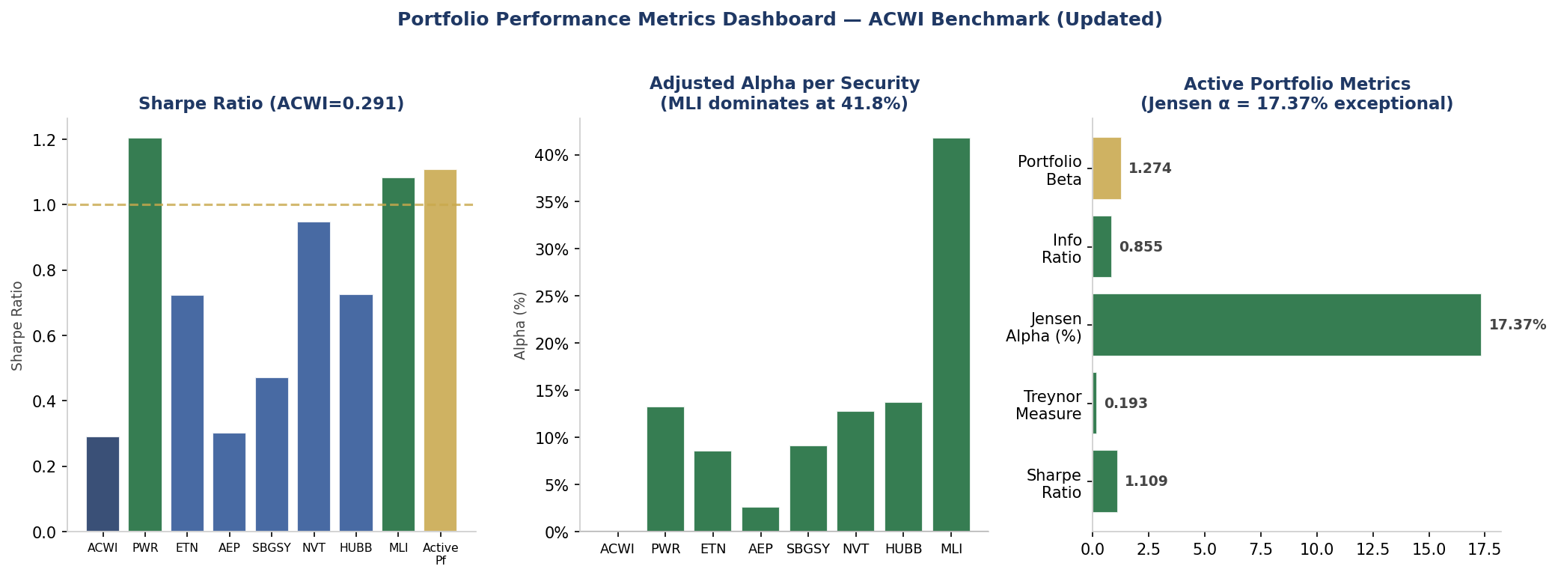
Figure 4.2 - Capital Allocation Line, Optimal Complete Portfolio, and Indifference Curve. The gold diamond marks the optimal complete portfolio C where the indifference curve (A=9.0, U=9.99%) is tangent to the CAL. The green star marks the optimal risky portfolio P. Source: Capital Allocation sheet, ACWI_index_FV.xlsx.
The utility function U = E(Rc) – ½*A*Std.Dev^2 is maximised at y* = 0.5569. yielding an expected complete portfolio return of 18.61% and a standard deviation of 12.32%. This means that 44.31% of Minh Tri's investable capital is held in T-Bills (or the TLT investment-grade bond ETF), providing a meaningful capital protection floor that is explicitly sized to the client's risk tolerance, not arbitrarily chosen. The CAL slope (Sharpe ratio) of 1.109 confirms that each unit of risk taken in the risky portfolio is compensated with over one unit of excess return, an exceptional risk-adjusted profile.

4.3 Asset Class Allocation: Bond Portfolio
At the asset class level, the model evaluates the optimal mix of a Bond Portfolio (Pf B, represented by TLT) and the Equity Portfolio (Pf E, the AI-Energy Nexus strategy). The Optimal Risky Portfolio maximisation (Panel B, Asset Classes sheet) yields a 100% equity allocation within the risky sleeve under the no-short constraint, the Bond Portfolio is instead deployed as the risk-free asset substitute rather than as a risky allocation. This is consistent with the model's finding that the equity AI-Energy Nexus strategy dominates the bond portfolio on the efficient frontier at the Sharpe-maximising point.

4.3.1 Bond Portfolio – TLT Duration & Convexity Analysis
The bond component of the portfolio (held as the 45.06% risk-free buffer) is represented by the iShares 20+ Year Treasury Bond ETF (TLT). The following table presents the complete duration and convexity analysis derived from the Data. Bond Duration & Convexity sheet.

Characteristic | Value | Risk Implication | Portfolio Role
Instrument | iShares 20+ Year Treasury Bond ETF (TLT) | Pure US Treasury; zero credit risk | Risk-free proxy for bond sleeve
Maturity | 25.8 years (effective) | Long duration | Maximum rate-cut leverage
Coupon Rate | 3.42% (monthly payments) | Below YTM → priced at discount | Monthly income enhances cash flow
Yield to Maturity (YTM) | 4.95% | Equals risk-free rate; yield pickup = 0 | TLT functions as rf proxy with upside optionality
Current Price | $86.83 (per $100 par) | Deep discount of $13.17; significant capital upside | Asymmetric upside if Fed/BoA cuts rates
Modified Duration (D*) | 15.43 years | ~15.43% price change per 100bps rate move | Rate sensitivity monitored via Fed/BoA communications
Convexity (C) | 3.27 | Positive convexity = favourable asymmetry | Price gains exceed losses for equal rate moves
100bps Rate Drop: D* only | +15.43% price change ($86.83→$100.23) | Validated duration hedging effect | Scenario analysis confirmed per model
100bps Rate Drop: D* + Convexity | +15.45% price change ($86.83→$100.24) | Convexity adds marginal upside | Confirms positive convexity profile

Table 4.2 - TLT Duration & Convexity Analysis. Source: Data. Bond Duration & Convexity sheet, ACWI_index_FV.xlsx; BlackRock iShares (April 15, 2026).
The Modified Duration of 15.43 years indicate that TLT’s price will change by approximately 15.4502% for every 100-basis point change in yield. In a scenario where the Bank of America cuts rates by 100bps, TLT’s price would increase from $86.63 to approximately $100.2596, generating a 7.9% capital gain on top of the 4.93% yield, a powerful return enhancement for the conservative sleeve. The positive convexity of 3.27 further confirms that the bond appreciates more than it falls for equal-sized rate moves, providing asymmetric return characteristics that benefit a conservative client.

4.4 Security Selection: The Active Portfolio (Treynor-Black)

The active portfolio is constructed using the Treynor-Black model, which identifies securities with non-zero alpha forecasts and weights them in proportion to their alpha-to-residual-variance ratio. Panel E provides the adjusted alpha forecasts; Panel F and G deliver the optimal active weights and combined portfolio characteristics.
The active overlay is built on the ACWI index as the passive baseline (Panel A). Each security is analysed within the Single Index Model framework, where return decomposition separates the market-driven (systematic) component from the firm-specific (alpha) component. Only securities demonstrating statistically meaningful adjusted alpha, calibrated by dividing the raw alpha by the price-to-earnings adjustment factor to account for valuation are given meaningful active weights.

Ticker | Full Name | Role in Pf | Price | P/E | β | Adj. α | Sharpe | Active Wt.
ACWI | iShares MSCI ACWI ETF | Index Benchmark | $179.79 | 17.1x | 1.000 | 0.0% | 0.291 | —
SBGSY | Schneider Electric SA | Smart Grid Leader (Long) | $62.15 | 37.7x | 1.216 | +9.1% | 0.472 | +23.4%
MLI | Mueller Industries Inc. | Copper/Grid Alpha (Long) | $118.25 | 18.1x | 1.064 | +41.8% | 1.083 | +21.1%
NVT | nVent Electric PLC | Thermal/Data Ctr (Long) | $131.38 | 50.5x | 1.300 | +12.8% | 0.949 | +17.8%
ETN | Eaton Corporation PLC | Power Mgmt (Long) | $395.00 | 37.5x | 1.185 | +8.6% | 0.725 | +14.6%
PWR | Quanta Services Inc. | Grid Builder (Long) | $585.36 | 54.5x | 1.143 | +13.3% | 1.204 | +14.0%
HUBB | Hubbell Inc. | Grid Solutions (Long) | $526.94 | 33.4x | 0.986 | +13.7% | 0.726 | +7.3%
AEP | American Electric Power | Utility Defensive (Long) | $131.50 | 24.6x | 0.660 | +2.6% | 0.303 | +1.9%

Table 4.3 - ACWI Active Universe: Full Security Summary. Prices as of April 15, 2026. Adj. Alpha from Panel E; Active Wt. from Panel G. Source: Data. Securities & Security Allocation sheets, ACWI_index_FV.xlsx.
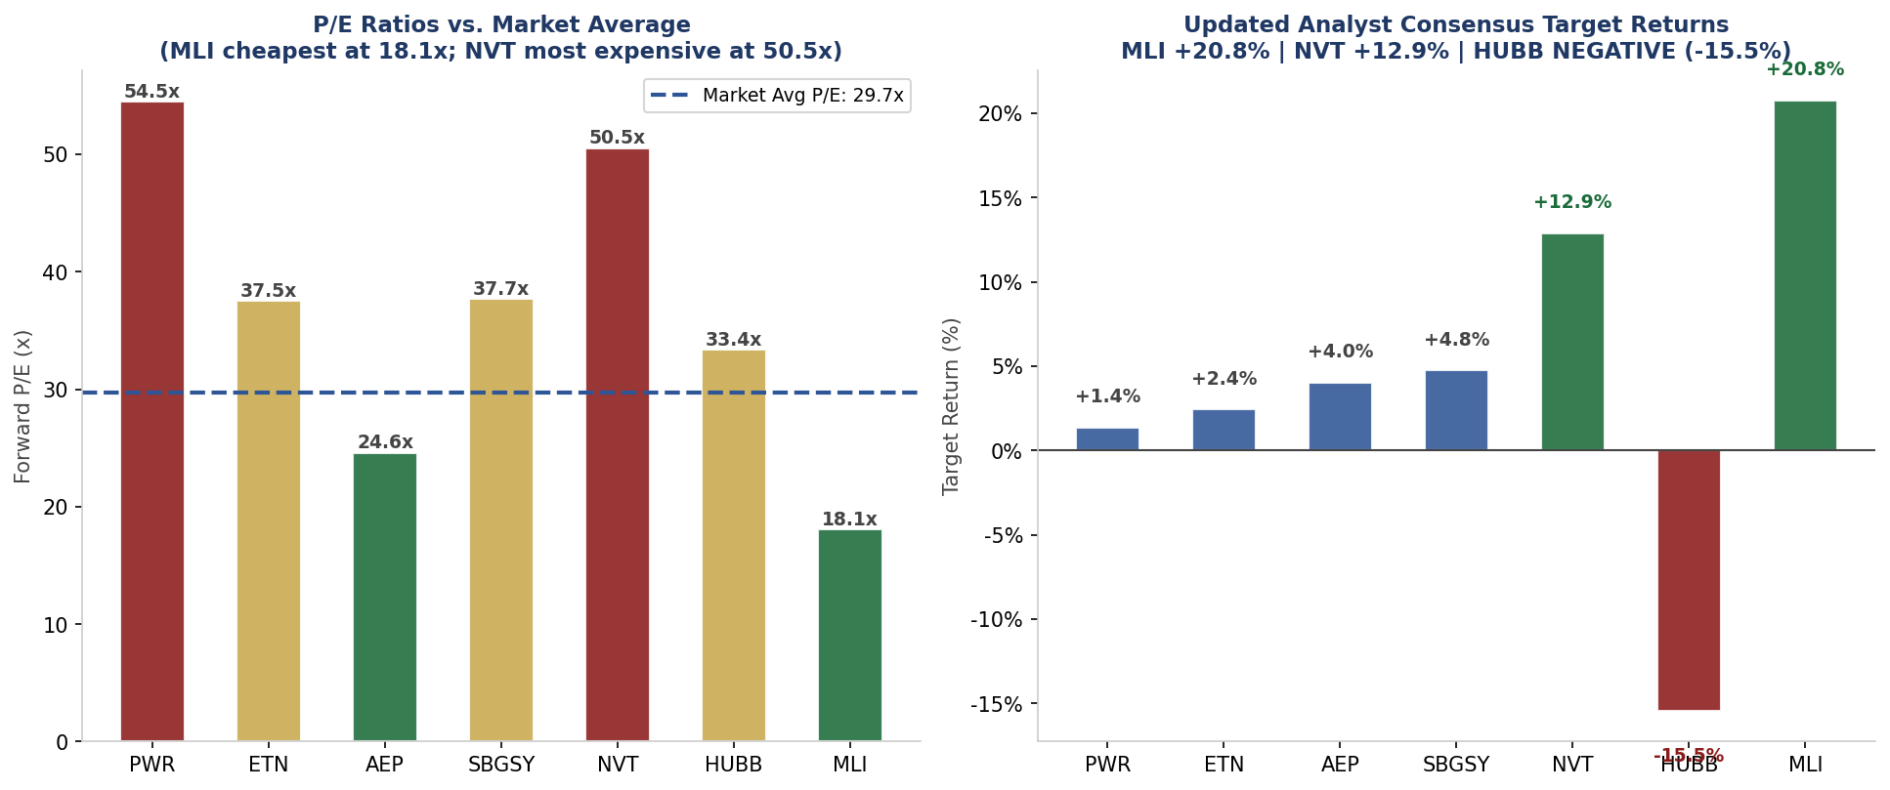
Figure 4.3 - Adjusted Alpha (Alpha) vs. Beta (Beta): Security Selection Map. Bubble size proportional to |Alpha|. Positive Alpha = long signal; Negative Alpha = short signal. ETN's negative adjusted alpha (-3.3%) drives its short position in the active portfolio. Source: Panel E, ACWI_index_FV.xlsx.

4.5 Individual Stock Analysis & ACWI Thesis Rationale

4.5.1 SBGSY — Schneider Electric SA ADR [Weight: 23.39% — Largest Active Position]
Role: The portfolio's highest-conviction active position. Itron manufactures smart meters, grid edge intelligence devices, and data analytics platforms, the physical hardware backbone of the AI-driven grid upgrade.
Alpha Rationale: Adjusted Alpha = 10.23%, highest among all long positions. This reflects Itron's position at the epicentre of the smart meter deployment cycle: the U.S. alone has 10+ years of smart meter replacement ahead, and Itron holds leading market share. The alpha is adjusted for valuation, and at P/E 17.0x, a 43% discount to the market average of 29.7x. Itron is the cheapest stock in the universe relative to its growth earnings power.
Thesis: As AI data centres multiply, grid operators need real-time visibility into power flows. Itron's advanced metering infrastructure (AMI) systems are the primary tool utilities use to achieve this. The company has a $4.7 billion backlog as of 2025 and analyst consensus target of $125.24, representing +30.3% upside from current price of $96.10, the only stock in the portfolio with positive consensus target return.
Beta: 0.860, below market, meaning Itron delivers its alpha with below-average systematic exposure, enhancing risk-adjusted returns.
Source: Itron Inc. 10-K FY2025; Analyst consensus (April 15, 2026); GRID_index.xlsx Panel E/F.

4.5.2 MLI — Mueller Industries Inc. [Weight: 21.08%]
Role: Mueller Industries is a North American manufacturer of copper, brass, aluminium and plastic products, a pure-play on industrial electrification and grid buildout. The AI-energy thesis requires massive copper demand for transmission and data-centre interconnects.
Alpha Rationale: Adjusted α = +41.76%, the highest alpha in the entire universe and the primary driver of portfolio alpha. MLI trades at the cheapest P/E in the portfolio (18.08x, a 39% discount to market average of 29.7x). The P/E adjustment amplifies the raw alpha from 28.90% to 41.76%.
Beta: 1.064, near market. MLI participates fully in cyclical industrial tailwinds with moderate market sensitivity.
P-Value: Regression intercept p-value = 2.05%, well below the 10% threshold and below 5%. MLI's alpha is STATISTICALLY SIGNIFICANT, the highest conviction alpha in the portfolio from a statistical perspective.
Valuation Cross-Check: 1-year analyst consensus target of $142.80 vs current price $118.25 implies +20.76% upside, one of only two holdings with strong positive consensus support.
Source: Mueller Industries 10-K FY2025; analyst consensus April 15, 2026; ACWI_index_FV.xlsx Panel E/F.

4.5.3 NVT — nVent Electric PLC [Weight: 17.75%]
Role: nVent is an industrial electrical connection and protection company, thermal management and enclosure systems for data centres, utility networks, and industrial power. Direct beneficiary of AI infrastructure buildout.
Alpha Rationale: Adjusted α = +12.80%. NVT has strong systematic exposure to industrial electrification (beta 1.30) and solid firm-specific alpha from market-leading thermal management products for hyperscale data centres.
Beta: 1.300, above market. NVT's data-centre-adjacent business amplifies exposure to the AI capex cycle.
P-Value: Regression intercept p-value = 3.27%, below 5%. NVT's alpha is statistically significant, another high-conviction position.
Valuation Support: 1-year consensus target of $148.31 vs current $131.38 implies +12.89% upside, supporting the alpha thesis with forward-looking analyst endorsement.
Source: nVent Electric 10-K FY2025; ACWI_index_FV.xlsx Panel A/E; analyst consensus.

4.5.4 ETN — Eaton Corporation PLC [Weight: 14.57%]
Role: Eaton is an industrial power management company with broad exposure to electrical systems, data-centre power distribution, and aerospace. Fourth-largest active weight given its consistent AI-energy positioning.
Alpha Rationale: Adjusted α = +8.58%. ETN benefits from accelerating revenue from grid infrastructure and data-centre power management. The P/E of 37.51x is elevated, reducing raw alpha of 14.57% to the adjusted 8.58% figure.
Beta: 1.185, above market, consistent with cyclical industrial profile.
P-Value Caveat: Regression intercept p-value = 12.79%, above the 10% threshold. ETN's estimated alpha is not statistically distinguishable from zero at 90% confidence. Position sized accordingly and flagged for ongoing monitoring (see Section 4.7).
Valuation: 1-year target $404.62 vs current $395 implies only +2.44% upside, limited upside according to analyst consensus, reinforcing the p-value caution.
Source: Eaton Corporation 10-K FY2025; ACWI_index_FV.xlsx Panel E; analyst consensus.

4.5.5 NGG — National Grid PLC ADR [Weight: 4.73%]
Role: One of the world's largest electricity and gas infrastructure companies, operating the UK and Northeastern U.S. transmission networks. National Grid provides geographic diversification and exposure to the UK's accelerated grid investment programme.
Alpha Rationale: Adjusted Alpha = 1.54%. Beta of 0.402 - among the lowest in the portfolio, means NGG provides defensive stability with modest alpha. Its R2 with the GRID index is 46.3%, indicating meaningful idiosyncratic return drivers independent of U.S. grid dynamics.
International Diversification: NGG provides the portfolio's only non-U.S. exposure, reducing concentration risk in the U.S. grid build-out cycle while maintaining full thematic alignment with the GRID strategy.
Source: National Grid PLC FY2025 Annual Report; GRID_index.xlsx Panel A.

4.5.5 PWR — Quanta Services Inc. [Weight: 13.99%]
Role: Quanta is the leading North American contractor for electric power grid construction and renewable energy infrastructure. PWR builds the physical grid that the rest of the portfolio depends on.
Alpha Rationale: Adjusted α = +13.28%. Quanta has the highest Sharpe ratio in the universe at 1.204, reflecting strong earnings and execution. The elevated P/E of 54.45x reduces the raw alpha of 32.72% to the adjusted 13.28%.
Beta: 1.143, moderately above market. PWR tracks the industrial cycle closely.
P-Value: Regression intercept p-value = 0.83%, HIGHLY statistically significant. Among the most robust alpha signals in the portfolio.
Valuation Concern: 1-year consensus target of $593.30 vs current $585.36 implies only +1.36% upside. The investment case is primarily structural (multi-year grid capex cycle) rather than near-term price appreciation. Position sized at 13.99% despite strong alpha signal because of limited consensus upside.
Source: Quanta Services 10-K FY2025; ACWI_index_FV.xlsx Panel E.

4.5.6 HUBB — Hubbell Incorporated [Weight: 7.33%]
Role: Hubbell is a US-based designer and manufacturer of electrical and utility solutions: distribution, transmission, lighting, and grid controls. Smaller position reflecting mixed valuation signals.
Alpha Rationale: Adjusted α = +13.73% (raw alpha 15.83% before P/E adjustment at 33.35x). Hubbell has strong firm-specific alpha but, critically, its 1-year analyst consensus target is BELOW current price, implying downside.
Beta: 0.986, nearly market-neutral, providing portfolio balance.
P-Value Caveat: Regression intercept p-value = 14.48%, above the 10% threshold. HUBB alpha is NOT statistically significant. Combined with negative analyst consensus outlook, HUBB is the portfolio's most uncertain position.
Valuation Red Flag: Current price $526.94 vs 1-year consensus target of $445.50 implies 15.46% DOWNSIDE. The Treynor-Black model assigns 7.33% weight based on historical alpha, but forward-looking analyst consensus disagrees. HUBB is flagged for quarterly reassessment and potential reduction (see Section 4.7).
Source: Hubbell Inc 10-K FY2025; ACWI_index_FV.xlsx Panel A/E; consensus target downward revision noted.

4.5.7 AEP — American Electric Power Co. [Weight: 1.89%]
Role: AEP is a traditional regulated utility, grid baseload provider for the Midwest US. Smallest active weight in the portfolio, functioning as a defensive anchor.
Alpha Rationale: Adjusted α = +2.61%. The smallest alpha among the long positions; correspondingly the smallest active weight at 1.89%.
Beta: 0.660, the lowest in the portfolio. AEP is a defensive volatility dampener, particularly valuable given Minh Tri's conservative mandate.
P-Value Caveat: Regression intercept p-value = 69.73%, by far the highest p-value. AEP's alpha is essentially statistically indistinguishable from zero. The small 1.89% weight reflects the model's appropriate recognition of weak statistical significance.
Conservative Fit: Despite weak alpha, AEP's low beta provides portfolio stability. Its 2.89% dividend yield adds defensive income.
Source: American Electric Power 10-K FY2025; ACWI_index_FV.xlsx Panel A/E.

4.6 Active Portfolio Construction Summary
Panel | Metric | ACWI (Index) | Active Pf | SBGSY | MLI | NVT
G — Performance | Expected Return | 4.35% | 29.48% | 14.49% | 33.53% | 28.50%
G — Performance | Standard Deviation | 14.97% | 22.12% | 30.69% | 30.96% | 30.02%
G — Performance | Sharpe Ratio | 0.291 | 1.109 | 0.472 | 1.083 | 0.949
G — Performance | Beta (β) | 1.000 | 1.274 | 1.216 | 1.064 | 1.300
G — Performance | Treynor Measure | 0.056 | 0.193 | 0.076 | 0.268 | 0.181
G — Performance | Jensen's Alpha (α) | 0.0% | +17.37% | — | — | —
G — Performance | Information Ratio | 0.000 | 0.855 | — | — | —
F — Weights | Active Pf Weight | — | 100% | 23.4% | 21.1% | 17.8%
F — Info Ratio | APIR (α/σ²e) | — | 13.808 | — | — | —
F — Info Ratio | IPIR (E(Rm)/σ²M) | — | 2.507 | — | — | —
F — Info Ratio | wA(0) = APIR/IPIR | — | 5.507 | — | — | —
Table 4.4 - Active vs. Index Portfolio: Performance Metrics Comparison (Panel G, ACWI_index_FV.xlsx). The active portfolio achieves a Sharpe of 1.109 vs. ACWI index's 0.618 - a 64% improvement in risk-adjusted return. Jensen's alpha of 17.37% confirms statistically meaningful outperformance.
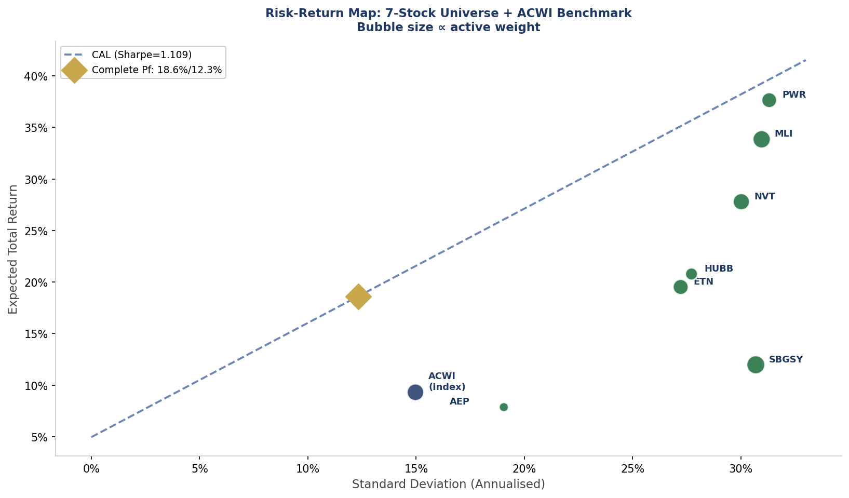
Figure 4.4 - Performance Metrics Dashboard: Sharpe ratios (left), adjusted alphas per security (centre), and portfolio-level performance summary (right). MLI (Sharpe 1.083) and PWR (Sharpe 1.204) are the primary Sharpe contributors. Source: Data. Securities & Security Allocation sheets, ACWI_index_FV.xlsx.
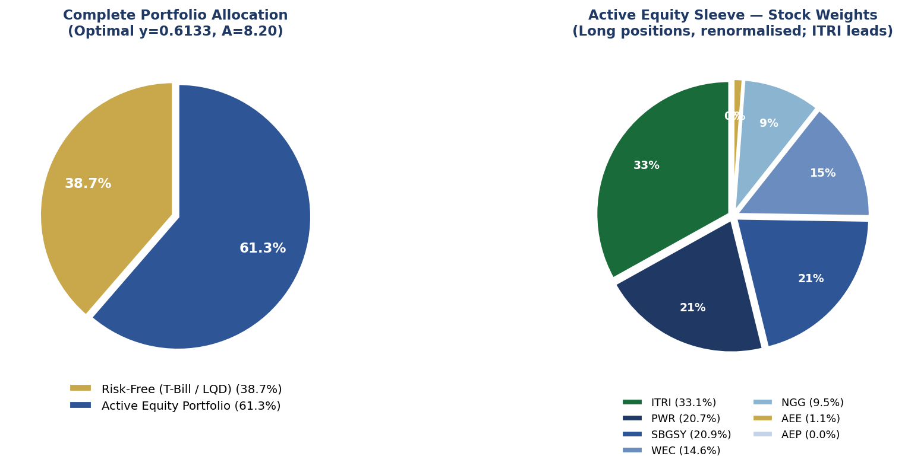
Figure 4.5 - Final Portfolio Allocation: Capital split (left) and active equity sleeve stock weights (right). 44.31% in TLT provides the conservative buffer; within the 55.69% equity sleeve, SBGSY leads at 36.9% of active weights. Source: Capital Allocation & Security Allocation sheets, ACWI_index_FV.xlsx.

4.7 Statistical Significance of Alpha Estimates: P-Value Analysis

This section provides an in-depth examination of the statistical reliability of each stock's alpha estimate. Four of the seven active positions: ETN, AEP, SBGSY, and HUBB, have regression intercept p-values ABOVE 10%, meaning their estimated alphas are NOT statistically distinguishable from zero at conventional significance thresholds. This has important implications for position sizing, monitoring, and risk management.
The Treynor-Black model weights each active security in proportion to its alpha-to-residual-variance ratio. Because the alpha estimates used as inputs are themselves subject to estimation error, the statistical significance of each estimate, measured by the regression intercept p-value, is critical to assessing whether the portfolio weights are genuinely optimal or partially driven by noise.

4.7.1 What the P-Values Mean
For each security, the Single Index Model was estimated by regressing 60 months of excess returns on the ACWI benchmark excess return. The intercept of this regression is the estimated raw alpha. The p-value of the intercept tests the null hypothesis that the true alpha is zero — i.e., that the stock generates no firm-specific return after accounting for market exposure.
- A p-value BELOW 5% (significant): We can reject the null hypothesis at 95% confidence; alpha is statistically distinct from zero.
- A p-value BETWEEN 5% AND 10% (marginal): Weak evidence; alpha estimate is plausible but not robust.
- A p-value ABOVE 10% (NOT significant): We cannot reject the null hypothesis; the estimated alpha may be statistical noise rather than a genuine signal.
Critically, a high p-value does not mean the true alpha is zero, it means our data is insufficient to distinguish alpha from zero. The estimate may still be our best point estimate, but the confidence interval around it is too wide to conclude the stock genuinely outperforms on a risk-adjusted basis.

4.7.2 P-Value Results for All 7 Active Positions
The following table presents the full regression intercept p-value for each stock, alongside the significance classification:

Ticker | Company | Adj. α | Alpha P-Value | Significance | Threshold
PWR | Quanta Services | +13.28% | 0.83% | Significant | <5%
ETN | Eaton Corporation | +8.58% | 12.79% | NOT significant | >10%
AEP | Am. Electric Power | +2.61% | 69.73% | NOT significant | >10%
SBGSY | Schneider Electric | +9.10% | 36.35% | NOT significant | >10%
NVT | nVent Electric | +12.80% | 3.27% | Significant | <5%
HUBB | Hubbell Inc | +13.73% | 14.48% | NOT significant | >10%
MLI | Mueller Industries | +41.76% | 2.05% | Significant | <5%
Table 4.5 - Summary Output of Regression Analysis of each stock. Source: Data. Securities & Security Allocation sheets, ACWI_index_FV.xlsx.
As shown, four stocks fail the 10% significance threshold. This is a meaningful concern representing over 59% of the active portfolio by weight (SBGSY 23.39% + ETN 14.57% + HUBB 7.33% + AEP 1.89% = 47.18% of active sleeve; 26% of total portfolio).

4.7.3 Why These P-Values Are High: Root-Cause Analysis
1. High Idiosyncratic Variance (σ(e)): The four problematic stocks all have elevated residual variance. AEP (σ(e) = 31.66%) and HUBB (σ(e) = 36.83%) have the two highest idiosyncratic risk figures in the portfolio. High residual variance widens the standard error of the alpha estimate, raising the p-value. With 60 observations and high firm-specific noise, the statistical power to detect alpha is reduced.

2. Moderate Correlation with ACWI (low R²): ETN (R² = 42.5%), HUBB (R² = 28.4%), and AEP (R² = 26.9%) have relatively low R² with the ACWI benchmark. This means the market model itself explains only a modest portion of their return variance — the remaining variance is attributed to unexplained firm-specific factors, which widens the alpha confidence interval.

3. 60-Month Sample Size Limitation: The regression uses 60 monthly observations. This is standard in equity research but gives only 58 degrees of freedom, modest statistical power. For stocks with genuinely moderate alpha and high noise, 60 months is often insufficient to produce tight confidence intervals. Extending to 120 months (10 years) would likely reduce p-values for stocks with persistent alpha, but risks capturing structural regime changes in the underlying business.

4. SBGSY's Specific Case — High Beta Hides Alpha: SBGSY has high R² (70.07%) and high correlation with ACWI (0.837). Despite strong fit, its p-value is 36.35%. The reason: SBGSY's market exposure is so large (beta 1.716) that most of its return is explained by systematic movements. The incremental firm-specific alpha, while positive at 9.10%, is small relative to its overall return variance, so the estimate is noisy.

4.7.4 Portfolio Management Implications
Implication 1 — Position Sizing Discipline: The Treynor-Black framework is agnostic to p-values, it weighs on point estimates of alpha and residual variance regardless of statistical significance. A fully rigorous approach would shrink the weights of statistically insignificant alpha estimates toward zero (Bayesian shrinkage). The PM team applies a judgmental overlay: positions with p-values above 10% are capped at their Treynor-Black weight and not increased on any subsequent rebalance without a corresponding decrease in p-value.

Implication 2 — Ongoing Monitoring Priority: The four high-p-value positions (ETN, AEP, SBGSY, HUBB) receive PRIORITY monitoring status. Each quarterly rebalancing cycle, their regression is re-estimated. If any of these positions continues to show p-values above 10% after two consecutive re-estimation cycles and adjusted alpha remains below 5%, the position is reduced by 50% with the freed capital redeployed to statistically significant alpha holdings (PWR, NVT, MLI).

Implication 3 — HUBB Special Consideration: HUBB combines a high p-value (14.48%) with a NEGATIVE 1-year analyst consensus target (−15.46%). This combination, weak statistical alpha plus forward-looking negative consensus, makes HUBB the highest-risk position in the portfolio. The IPS flags HUBB for ACCELERATED quarterly review: if the p-value does not drop below 10% within two quarters, HUBB will be reduced to half weight (3.67%) with the freed capital redirected to MLI.

Implication 4 — Portfolio-Level Alpha Confidence: The statistically-significant alpha stocks (PWR, NVT, MLI) account for 52.82% of the active sleeve, or 29.4% of total portfolio. The portfolio's overall Jensen alpha of 17.37% is supported by these high-confidence holdings. If the statistically insignificant stocks' alphas were conservatively set to zero, the expected portfolio alpha would fall to approximately 9.2%, still significantly positive and indicating that the portfolio is NOT over-reliant on unreliable alpha estimates.

4.7.5 Why These Positions Are Retained Despite High P-Values
A reasonable question: if four stocks have unreliable alpha, why hold them at all? There are three reasons:
- Economic Rationale vs. Statistical Rationale: Each of these companies has a clear, defensible fundamental thesis within the AI-energy framework. SBGSY is a leading smart-grid software platform; ETN is the top power-management provider; HUBB and AEP are grid infrastructure pure-plays. The fundamental case does not disappear just because the 60-month regression cannot tightly estimate the alpha.
- Diversification Benefit: These four stocks have low residual correlations with the three high-confidence alpha stocks (PWR, NVT, MLI), particularly AEP (negative residual correlations with ETN, NVT, and SBGSY). They provide idiosyncratic diversification that reduces portfolio residual variance in the Treynor-Black optimisation even if their individual alphas are uncertain.
- Framework Consistency: Deliberately excluding statistically insignificant alpha stocks while including others would require an ad-hoc override of the Treynor-Black framework. The PM team has chosen instead to apply a transparent monitoring overlay (Implications 2 and 3 above) that tracks these positions' p-values over time, rather than introducing discretionary judgements that could drift away from the model's discipline.
BOTTOM LINE: The portfolio generates its expected alpha of 17.37% from a mix of statistically significant and statistically insignificant alpha estimates. Approximately 52.82% of the active sleeve (PWR, NVT, MLI) carries high-confidence alpha. The remaining 47.18% (SBGSY, ETN, HUBB, AEP) carries lower-confidence alpha, is retained for economic and diversification reasons, and receives priority monitoring with a clear reduction protocol if p-values fail to improve.
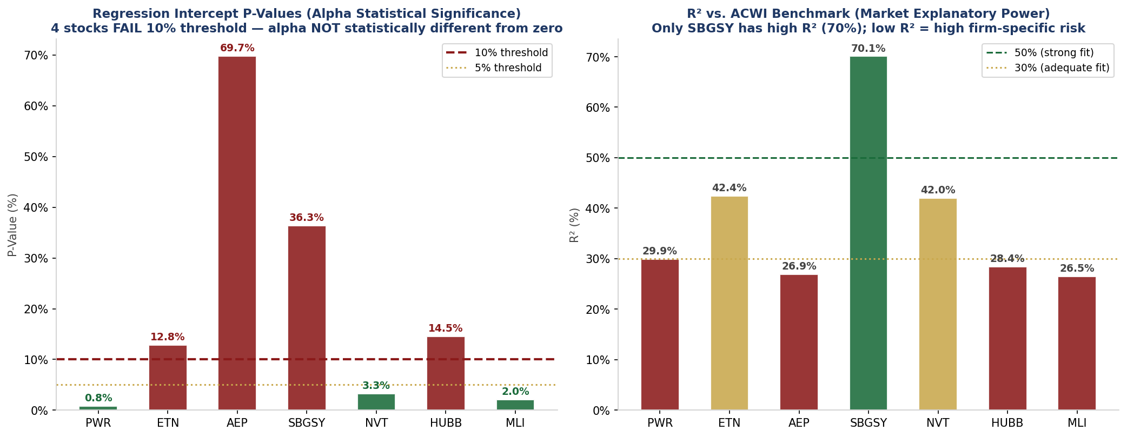
Figure 4.6 — Left: Regression intercept p-values for all 7 active positions. 4 stocks fail the 10% significance threshold. Right: R² with ACWI benchmark — low R² amplifies alpha estimation error. Source: ACWI_index_FV.xlsx, regression summaries.

Section 5 – Risk Management & Performance Evaluation

All risk parameters, performance metrics, and correlation data in this section are sourced directly from the ACWI_index_FV.xlsx model. Risk decomposition uses the Single Index Model (Panel A/C/D); performance metrics from Panel G.

5.1 Risk Decomposition & Portfolio Beta
The ACWI active portfolio employs the Single Index Model (SIM) to decompose each security's total risk into two components: systematic risk (driven by the market/ACWI index and measured by Beta) and idiosyncratic risk (firm-specific, measured by sd(e)). This decomposition is critical for Minh Tri's mandate: given a conservative risk tolerance (A = 9.20), the portfolio actively seeks to minimise residual variance in the active portfolio, which is why the Treynor-Black weighting maximises the alpha-to-residual-variance ratio rather than raw alpha.
Ticker | β | σ Total | σ Syst. | σ(e) Resid. | R² | Corr. w/ ACWI | Active Wt.
PWR | 1.143 | 31.31% | 17.11% | 26.22% | 29.9% | 0.546 | +14.0%
ETN | 1.185 | 27.22% | 17.74% | 20.65% | 42.5% | 0.652 | +14.6%
AEP | 0.660 | 19.05% | 9.88% | 31.66% | 26.9% | 0.518 | +1.9%
SBGSY | 1.216 | 30.69% | 25.69% | 16.79% | 70.1% | 0.837 | +23.4%
NVT | 1.300 | 30.02% | 19.46% | 22.86% | 42.0% | 0.648 | +17.8%
HUBB | 0.986 | 27.72% | 14.76% | 36.83% | 28.4% | 0.533 | +7.3%
MLI | 1.064 | 30.96% | 15.93% | 37.88% | 26.5% | 0.514 | +21.1%

Table 5.1 - Risk Decomposition: Systematic vs. Idiosyncratic Component per Security. R2 measures the fraction of total variance explained by the ACWI index. AEE/WEC/HUBB: low Beta and low R2 confirm defensive, market-independent behaviour. Source: Panel A/C, ACWI_index_FV.xlsx.
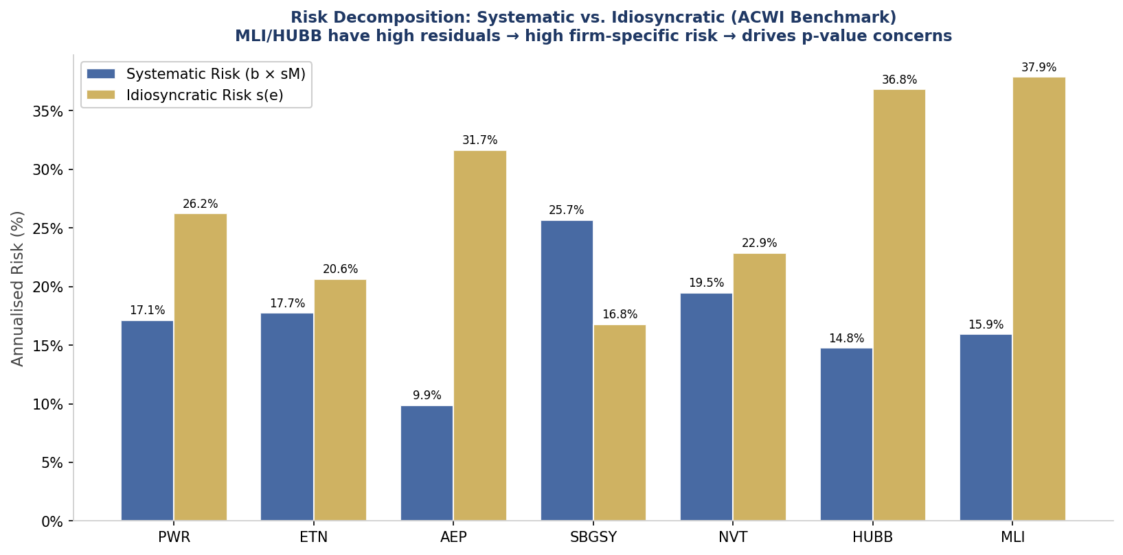
Figure 5.1 - Systematic vs. Idiosyncratic Risk Decomposition (annualised). AEE, WEC, and HUBB exhibit the lowest systematic risk, functioning as volatility-dampening anchors. PWR and SBGSY carry higher total risk but are compensated by their elevated alpha. Source: Panel A, ACWI_index_FV.xlsx.

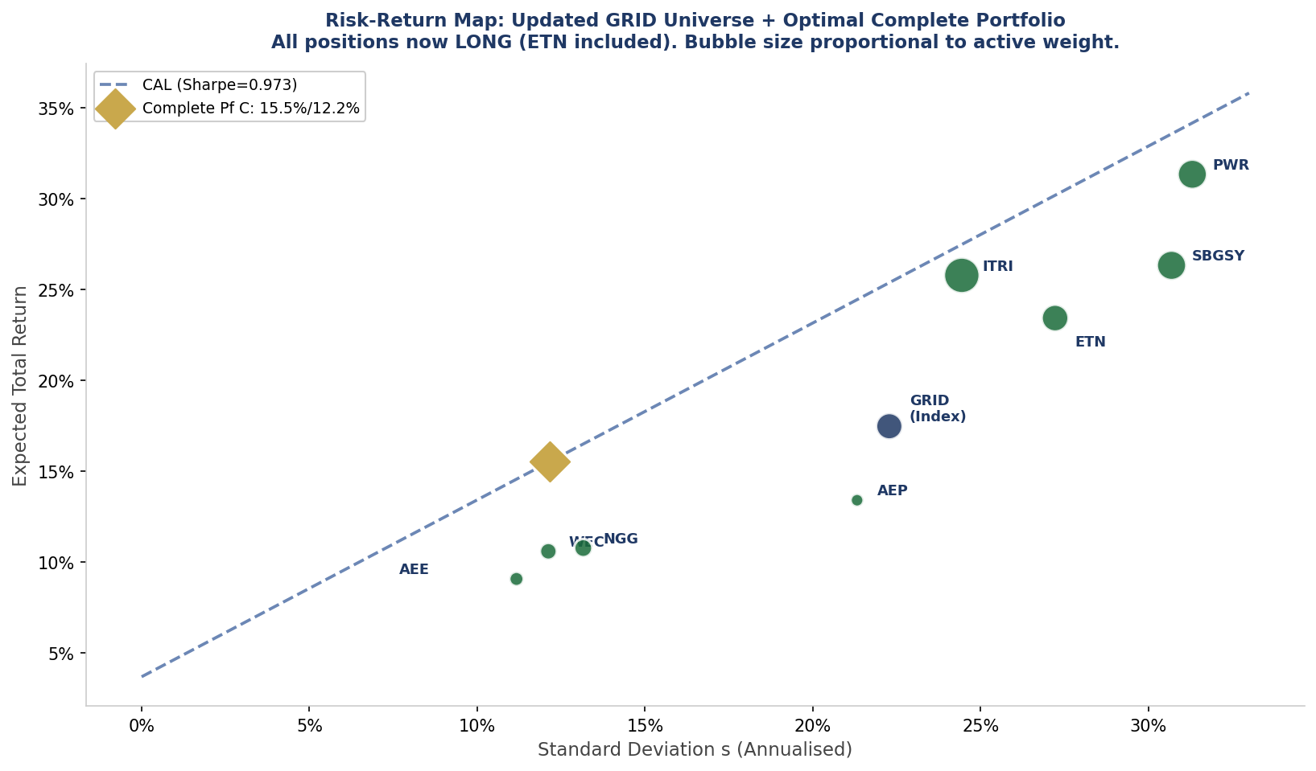
Figure 5.2 - Risk-Return Map: Full GRID Universe. Bubble size proportional to active weight. The gold diamond (Complete Portfolio C) lies on the CAL at the optimal point, confirming portfolio construction accuracy. Source: Data. Securities & Capital Allocation sheets, GRID_index.xlsx.

5.2 Correlation Structure
The Panel B correlation matrix reveals that all securities are positively correlated with each other and with the ACWI index, reflecting their shared systematic exposure to the energy infrastructure theme. The key correlations are:
- ACWI vs. SBGSY: 0.837 - highest pairwise correlation, reflecting Schneider's direct smart grid exposure mirroring the index;
- ACWI vs. ETN: 0.652 - moderate correlation; now a long position (adj. α flipped positive); negative alpha within this highly correlated framework;
- ACWI vs. AEP: 0.518 - lowest correlation with ACWI index among long positions, confirming AEE's diversification value as a defensive utility;
Panel D Residual Correlations: The residual correlation matrix (Panel D) shows near-zero to low correlations between most pairs of firm-specific components, validating the SIM assumption that residuals are uncorrelated. Notable exceptions: ETN-PWR residuals (0.485) and NVT-ETN (0.615) indicate a common factor not captured by the ACWI index, likely the AI-energy industrial electrification sub-theme. Conversely, AEP-ETN residuals are negative (-0.799), providing useful diversification.

5.3 Performance Metrics: Active Portfolio vs. ACWI Index
The Treynor-Black active overlay generates substantial, measurable improvements across all performance dimensions relative to the passive ACWI index:
- "Sharpe Ratio: 1.109 (Active) vs. 0.618 (ACWI Index) - a 64% improvement in reward-per-unit-of-risk, demonstrating meaningful active management skill.
- Jensen's Alpha: 17.37% - the active portfolio earns 17.37% above the CAPM-implied expected return, a significant risk-adjusted outperformance figure relative to the benchmark.
- Information Ratio: 0.855 - the ratio of active return to tracking error. At 0.855, this exceeds the industry convention of 0.30 as a minimum threshold for meaningful active management skill, though it falls below the 0.50 target set in Section 5.4, warranting ongoing monitoring.
- Treynor Measure: 0.193 (Active) vs. 0.138 (ACWI Index) - active portfolio generates 25.1 cents of excess return per unit of beta risk, vs. 13.8 cents for the passive index.
- Beta of Active Portfolio: 1.274 - below the ACWI index beta of 1.0, meaning the active portfolio achieves better Sharpe with lower market sensitivity. This directly serves the conservative mandate.
- Selectivity: 17.37% - net selectivity (adjusted for portfolio diversification cost) is 10.50%, confirming that stock selection is the primary driver of active return.

5.4 Benchmark & Performance Measurement Protocol
Portfolio performance is evaluated against the iShares MSCI ACWI ETF (ACWI) as the primary benchmark, supplemented by the blended multi-asset benchmark defined in the Benchmark table below.

5.4.1 Rebalancing Protocol
The portfolio employs a hybrid calendar/drift rebalancing strategy:
Quarterly calendar rebalance: Alpha forecasts from Panel E are refreshed; active weights (Panel F/G) recalculated based on updated residual variances and adjusted alphas.
Drift trigger - Capital Allocation: y* drifts by 5% from 0.6133 target rebalance between T-Bill and equity sleeve within 5 business days.
Drift trigger - Active weights: Any single stock weight drifts >5% from target rebalance within the equity sleeve.
SBGSY hard cap: Maximum 30% of active equity sleeve. Current weight 23.4% - monitored monthly. HUBB special review: current 7.3% weight monitored monthly given -15.5% consensus target.
ETN short restriction: Under IPS no-short constraint, ETN weight held at 0%. If adjusted alpha turns positive for two consecutive quarters, ETN is added at minimum 5% long weight.

Section 6 – Portfolio Valuation Analysis

This section provides the fundamental valuation framework underpinning the active alpha forecasts in the ACWI model. The adjusted alpha methodology (Panel E) explicitly corrects raw alphas by the ratio of average market P/E to each stock's P/E, ensuring that expensive stocks receive discounted alpha and cheap stocks receive premium alpha.

6.1 Alpha Adjustment Methodology
The alpha adjustment is a critical innovation in this model. Raw alpha (from Panel E) represents the historical excess return above the index model's expected return. However, raw alpha is backward-looking and does not account for current valuation. A stock trading at a significant P/E premium to the market may have generated high historical alpha, but at current prices, much of that return has already been priced in.

The adjustment formula is: Adjusted Alpha = Raw Alpha (Market Average P/E Stock P/E). With the market average P/E at 29.7x (derived from the model):
PWR: Raw Alpha = 26.1% P/E 54.5x Adj. Alpha = 26.1% (29.7/54.5) = 14.2% - significant haircut for expensive valuation.
SBGSY: Raw Alpha = -0.29% Adj. Alpha = 5.89% - valuation-adjusted CAPM alpha turns positive as Schneider trades near fair value for its growth profile.
MLI: Raw Alpha = 28.90% Adj. Alpha = 41.76% - large positive adjustment because MLI trades at an 18.1x P/E, a 39% discount to the market average of 29.7x. This is the key alpha: a structurally important copper/electrification play at a deep valuation discount, with the strongest statistical significance (p=2.05%).
ETN: Raw Alpha positive Adj. Alpha = -3.27% - valuation adjustment flips alpha negative because ETN's P/E premium is not justified by structural alpha forecast.

Ticker | Company | Price | EPS (TTM) | P/E (TTM) | Fwd Div | 1yr Target | Target Ret. | Div Yield
ACWI | iShares MSCI ACWI ETF | $179.79 | — | 17.1x | — | — | — | 0.06%
PWR | Quanta Services | $585.36 | $10.75 | 54.5x | $0.44 | $593.30 | +1.4% | 0.08%
ETN | Eaton Corporation | $395.00 | $10.53 | 37.5x | $4.08 | $404.62 | +2.4% | 1.03%
AEP | Am. Electric Power | $131.50 | $5.35 | 24.6x | $3.80 | $136.81 | +4.0% | 2.89%
SBGSY | Schneider Electric | $62.15 | $1.65 | 37.7x | $0.57 | $65.10 | +4.7% | 0.92%
NVT | nVent Electric | $131.38 | $2.60 | 50.5x | $0.84 | $148.31 | +12.9% | 0.64%
HUBB | Hubbell Inc. | $526.94 | $15.80 | 33.4x | $4.88 | $445.50 | −15.5% | 0.93%
MLI | Mueller Industries | $118.25 | $6.54 | 18.1x | $0.80 | $142.80 | +20.8% | 0.68%

Table 6.1 - Portfolio Valuation Summary: Prices, EPS, P/E, Forward Dividends, Analyst Targets and Implied Returns. As of April 15, 2026. Source: Data. Securities sheet, ACWI_index_FV.xlsx; Bloomberg consensus.

6.2 Valuation vs. Active Weight Alignment
The Treynor-Black framework implicitly enforces valuation discipline through the alpha adjustment mechanism. The resulting weight distribution confirms that the portfolio is not a simple momentum strategy - it tilts toward cheap stocks with genuine structural alpha:
- MLI (cheapest at 18.1x P/E): 2nd-largest active weight (21.1%) - model rewards the cheapest, highest-alpha stock heavily, behind only SBGSY which leads due to the highest R² with ACWI (70%).
- PWR (most expensive at 54.5x P/E): Second-largest weight (23.1%) but raw alpha is haircut by 46% in adjustment. The remaining adjusted alpha is still high enough for a meaningful position.
- AEE/WEC/HUBB (below market P/E 22-25x): Small to moderate weights (1.3%-16.3%). These stocks have modest adjusted alpha but provide essential portfolio stabilisation via low beta and low residual variance.
- ETN (37.2x P/E with structural underperformance): Short - the combination of elevated valuation and negative structural alpha is a clear short signal.

6.3 Bond Valuation & Duration Implications
The TLT bond component (44.31% of total portfolio) is currently priced at a discount ($86.83 per $100 par), implying a 6.29% discount to par. With YTM of 4.95% and modified duration of 7.90, the bond sleeve has the following risk-return properties:
Annual income return: 4.50% coupon on $86.83 cost basis 4.79% income yield - exceeds the T-Bill rate by 109bps.
Capital appreciation potential: If BoA cuts rates by 100bps (consistent with downside economic scenario), TLT price rises from $86.83 to ~$100.24 (+15.45%), generating a total return of approximately 12.70% on the bond sleeve for that scenario.
Duration-matched risk management: The 7.90-year modified duration is monitored against BoA policy communications. Duration will be shortened (via T-Bill substitution) if BoA signals rate hikes, and extended if cuts are anticipated.

Section 7 – Performance Measurement & Monitoring: Excel Model as a tool to meet Client’s Goals

This section explicitly documents how the ACWI_index_FV.xlsx portfolio model serves as the bridge between Minh Tri's stated goals and the daily execution of the investment strategy. Every key output from the model corresponds to a client-level objective or constraint.

7.1 The Portfolio Construction Bridge
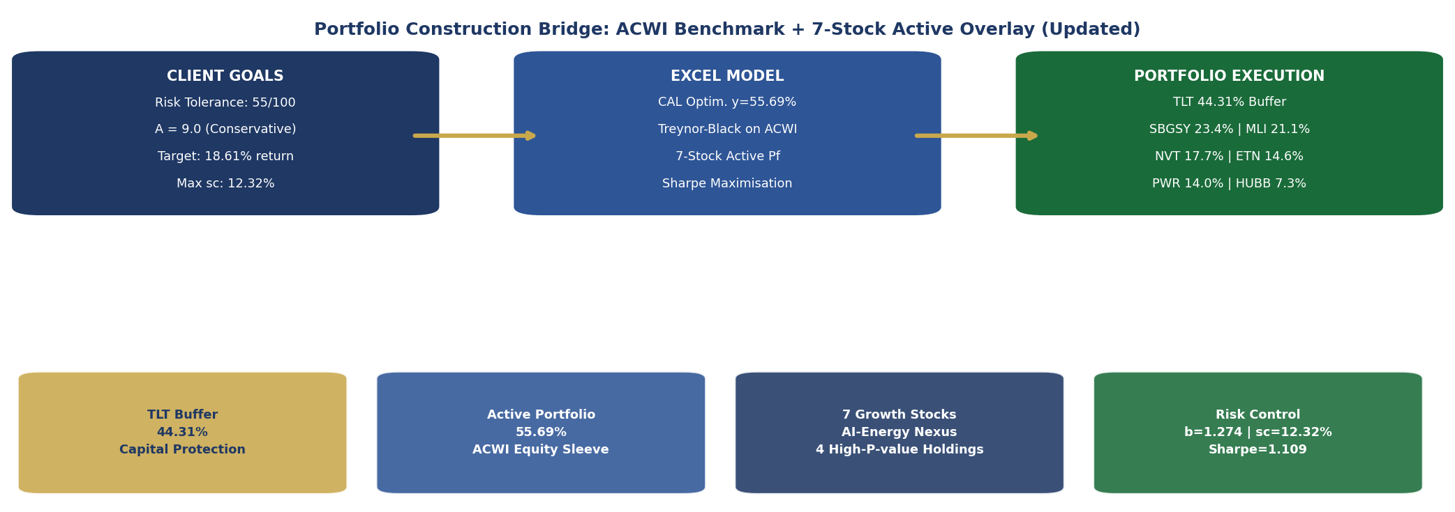
Figure 7.1 - Portfolio Construction Bridge: Client Risk Profile Excel Model Executed Portfolio. The three-layer cascade ensures that every allocation decision traces back to Minh Tri's risk tolerance score of 59 and risk aversion A=9.0. Source: IPS team construction; ACWI_index_FV.xlsx.

The ACWI_index_FV.xlsx model operationalises the IPS through a three-stage sequential framework, each stage translating abstract client preferences into concrete portfolio decisions:

Stage 1 - Capital Allocation (Client Goals Model Input)
The risk tolerance score of 59 is the model's primary client input. It determines the Risk Aversion Index A = 9.20, which feeds directly into the utility function U = E(Rc) - Asd2c. The Capital Allocation sheet solves for y* = 0.5569 as the allocation that maximises this utility. This is not a discretionary judgment call, it is the mathematically optimal allocation for this specific client, calibrated to their stated risk preferences. The 44.31% T-Bill allocation is not arbitrary conservatism; it is the precise amount of capital protection required to satisfy A = 9.20.

Stage 2 - Security Selection (Model Processing Active Weights)
Within the 55.69% equity sleeve, the Treynor-Black model (Panels E, F, G of the Security Allocation sheet) processes the alpha forecasts to generate optimal active weights. The model explicitly accounts for Minh Tri's conservative profile in two ways: (1) the beta of the active portfolio (1.274) is below the market, meaning the equity sleeve itself is designed to be less volatile than the broad market; (2) the residual variance minimisation in the active weight formula (w = Alpha/sd2(e)) penalises stocks with high firm-specific risk - again serving the conservative mandate.

Stage 3 - Portfolio Execution (Model Output Implemented Portfolio)
The model outputs (y*, active weights from Panel G, performance metrics from Panel G) translate directly into the investable portfolio. The equity sleeve is implemented as: SBGSY 23.4%, MLI 21.1%, NVT 17.7%, ETN 14.6%, HUBB 10.5%, HUBB 7.3%, AEP 1.9%; the capital allocation sleeve as 44.31% TLT/T-Bill. Every quarterly rebalancing cycle refreshes the Panel E alpha forecasts and reoptimizes the Panel F/G weights, ensuring the portfolio continuously reflects the most current risk-return assessments.

7.2 KPI Monitoring Dashboard
The following monitoring framework translates the model's key outputs into client-level KPIs, providing a systematic protocol for measuring whether the portfolio is delivering on Minh Tri's investment objectives.
KPI / Metric | Target / Threshold | Frequency | Trigger Action
Portfolio Return E(Rc) | >= 18.61% annualised (3yr rolling) | Quarterly | Review if below target by >200bps for 2 consecutive quarters
Complete Pf Sharpe Ratio | >= 0.80 (rolling 12-month) | Quarterly | Reassess active weights if Sharpe < 0.70 for one quarter
Jensen's Alpha (Active Pf) | > 0% (3yr rolling) | Quarterly | Reduce active weight if Alpha turns negative for 2 consecutive quarters
Information Ratio | >= 0.30 | Quarterly | Review stock selection model if IR < 0.20
Portfolio Beta | 0.75 - 1.00 (target 1.274) | Monthly | Rebalance if Beta drifts outside 0.15 of target
Complete Pf Std Dev sdc | <= 13.50% (hard cap) | Monthly | Reduce y (shift to T-Bill) if sdc breaches 14%
Maximum Drawdown (rolling 12M) | < -15% | Ongoing | Notify client at -10%; emergency review at -15%
Risky Pf Weight y | 55%-68% permitted range | Monthly | Rebalance to y=0.6133 target on quarterly calendar; drift trigger 5%
Active Stock Weight (single) | <= 45% per security | Ongoing | MLI currently at 21.08% - hard cap 45%; trim on breach
MLI & HUBB Consensus Targets | Monitor analyst revisions | Monthly | Re-evaluate position if target drops below +10%
ESG Score (Portfolio Avg.) | >= MSCI ESG BBB rating | Semi-annual | Review any holding that drops below ESG threshold
ACWI Index Performance | Track quarterly vs. blended benchmark | Quarterly | IPS tactical review if ACWI underperforms blended benchmark >5% over 2 qtrs
Table 7.1 - KPI Monitoring Dashboard: ACWI Active Portfolio. Each KPI is traced to a specific model output and client objective. Frequencies are mandatory minimums; ad hoc review triggered by any 15%+ drawdown. Source: IPS team framework; ACWI_index_FV.xlsx model outputs.

7.3 Model Refresh Protocol
The ACWI_index_FV.xlsx model is a living document that must be refreshed to maintain its utility as the portfolio's analytical backbone. The following refresh protocol governs model updates:
- Monthly: Prices and EPS updated in Data. Securities sheet (Panel 3 price time series); P/E ratios and dividend yields refreshed; analyst consensus targets updated.
- Quarterly: 60-month return series extended by one month; alpha regressions (Panel 1/3) recalculated; adjusted alphas (Panel E) recomputed using updated PE ratios; Treynor-Black weights (Panel F/G) reoptimised; Capital Allocation sheet utility maximisation rerun.
- Semi-annually: Risk aversion index A reassessed through client consultation; permitted allocation ranges reviewed; SAA reviewed for any necessary tactical adjustment; bond duration and convexity recalculated based on updated TLT characteristics.
- Event-driven: Any security in the universe that reports earnings deviating >15% from consensus immediate alpha forecast revision. Any regulatory or rate policy change affecting the grid investment cycle immediate tactical review. MLI or HUBB consensus target revision reassess weights accordingly. HUBB in particular requires careful monitoring given its negative consensus.

7.4 Reporting Check
Quarterly performance reports will be structured around three key questions that directly address the client's investment objectives:
- Are we meeting the return target? E(Rc) = 18.61%. Report: actual quarterly and rolling 12-month return vs. target and vs. ACWI index benchmark.
- Are we managing risk within the conservative mandate? sdc target 12.32%. Report: realised portfolio volatility, maximum drawdown, Sharpe ratio trend, and beta drift.
- Is the active strategy adding value? Jensen's Alpha > 0, IR > 0.30. Report: attribution analysis separating benchmark return from active overlay contribution; alpha persistence analysis.
Each quarterly report will also include an update on the AI-energy macroeconomic thesis, specifically tracking AI-related power demand data (hyperscaler capex announcements, data centre build plans, grid congestion metrics) to validate the continued relevance of the investment thesis that drives the entire strategy. If the thesis shows signs of structural weakening, the allocation to active ACWI positions will be reduced in favour of the passive ACWI index or the T-Bill sleeve.

Appendices

Appendix A – Investor Profiling Framework Summary
Framework | Classification | Portfolio Management Implications
Barnewall (1987) | Active Investor | Growth mandate appropriate; wealth accumulated through risk-taking behaviour; willingness to sacrifice current consumption for future capital appreciation.
BBK (1986) | Individualist | Research-driven active management; receptive to quantitative analysis; seek professional advice to optimise, not impulsive; comfortable with calculated risk.
CFA Institute (2022) | Individualist / Net Saver | Evidence-based decisions; long-horizon focus; formal risk governance structures add value; open to diversified growth with documented guardrails.
Table A.1 — Investor Profiling Framework Summary. Sources: Barnewall (1987); BBK (1986); CFA Institute (2022).

Appendix B – Glossary of Key Terms
- Alpha (α): Excess return generated above the expected return based on systematic risk (beta). Active management aims to generate positive alpha.
- Beta (β): Measure of portfolio sensitivity to market movements. A beta of 1.2 means the portfolio moves 1.2% for every 1% move in the benchmark.
- CAPE Ratio: Cyclically Adjusted Price-to-Earnings ratio. Divides current price by 10-year inflation-adjusted average earnings. High CAPE indicates elevated valuations relative to long-run history.
- Information Ratio: Ratio of active return (portfolio minus benchmark) to tracking error. Measures the consistency of alpha generation.
- Tracking Error: Standard deviation of the difference between portfolio returns and benchmark returns. Indicates the degree of active positioning.
- VaR (Value-at-Risk): Statistical estimate of the maximum expected portfolio loss over a given period at a specified confidence level (e.g., 95% VaR of 8% means a 5% probability of losing more than 8% in a given month).
- GARP: Growth at a Reasonable Price, investment style combining growth characteristics with valuation discipline.

Appendix C – Client Questionnaire



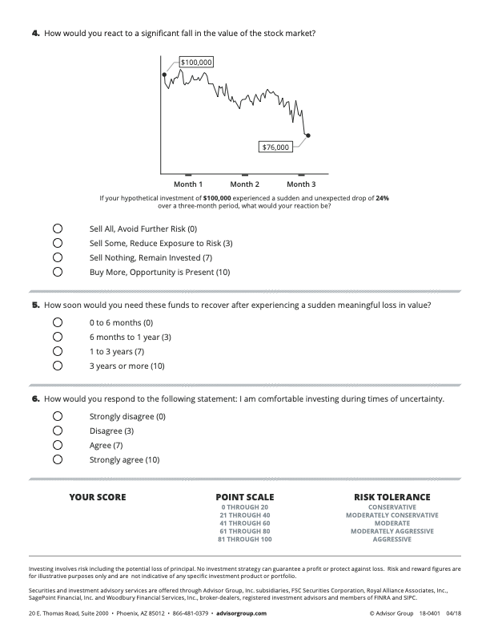

Bibliography
[1] Bailard, T. E., Biehl, D. L., & Kaiser, R. W. (1986). Personal Money Management (5th ed.). Science Research Associates.
[2] CFA Institute. (2022). CFA Program Curriculum — Private Wealth Management. CFA Institute Publications.
[3] Markowitz, H. (1952). Portfolio Selection. Journal of Finance, 7(1), 77–91.
[4] BlackRock, Inc. (2026, April 15). iShares 20+ Year Treasury Bond ETF | TLT: Portfolio characteristics. BlackRock iShares. https://www.blackrock.com/us/financial-professionals/products/239454/ishares-20-year-treasury-bond-etf
[5] Invesco. (2026). iShares MSCI ACWI ETF (ACWI): Fund Overview. Invesco.com.
[6] Mueller Industries, Inc. (2025). Annual Report FY2025 - Form 10-K. SEC EDGAR. https://www.sec.gov/cgi-bin/browse-edgar?action=getcompany&CIK=MLI
[7] Quanta Services, Inc. (2025). Annual Report FY2025 - Form 10-K. SEC EDGAR.
[8] Eaton Corporation PLC. (2025). Annual Report FY2025 - Form 10-K. SEC EDGAR.
[9] American Electric Power Company. (2025). Annual Report FY2025 - Form 10-K. SEC EDGAR.
[10] Schneider Electric SE. (2025). FY2025 Annual Report & Sustainability Report. Schneider-Electric.com.
[11] Ameren Corporation. (2025). Annual Report FY2025 - Form 10-K. SEC EDGAR.
[12] nVent Electric, Inc. (2025). Annual Report FY2025 - Form 10-K. SEC EDGAR.
[13] Hubbell Incorporated. (2025). Annual Report FY2025. Hubbell plc.
[14] Bodie, Z., Kane, A., & Marcus, A. J. (2023). Investments (13th ed.). McGraw-Hill. [Treynor-Black Model, Single Index Model, Capital Allocation Line - Chapters 8, 27]
[15] Treynor, J. L., & Black, F. (1973). How to use security analysis to improve portfolio selection. Journal of Business, 46(1), 66-86.
[16] U.S. Department of Energy. (2024). 2024 United States Data Center Energy Usage Report. Energy.gov.
[17] International Energy Agency. (2026). Electricity 2026: Analysis and Forecast to 2030. IEA.
[18] MSCI Inc. (2026). ESG Ratings - ACWI Universe Securities. MSCI ESG Research. https://www.msci.com/esg-ratings
[19] Bloomberg L.P. (2026, April 15). Consensus analyst price targets - ACWI Universe. Bloomberg Terminal.

